COLORADO EMERGENCY MANAGEMENT ASSOCIATION
Colorado Certified Emergency Manager / Associate Emergency Manager
Requirements Guide

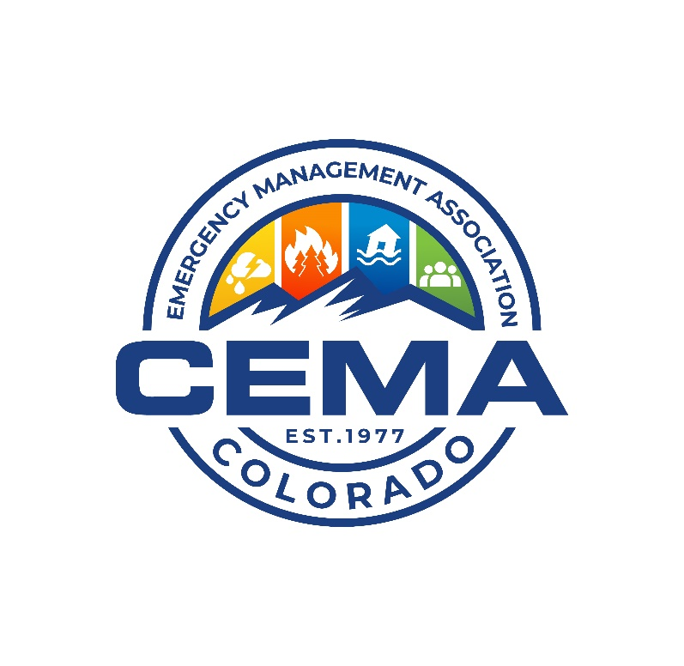

Table of Contents
Overview 1
Initial Application 1
Recertification 3
International Association of Emergency Managers Reciprocity 3
Appendix A - Resources A-1
Training Resources A-1
FEMA Training Course Options A-1
College Credit as Training A-2
Appendix B – Professional Contributions A-1
Contributions A-1
Documentation of Contributions A-1
Categories and Multiple Submissions A-1
Documentation Submission A-2
Reference Letters A-2
Contribution Requirements A-2

Overview
This guide is designed to support Colorado emergency managers in compiling their packets for submission of the Colorado Certified Emergency Manager (CO-CEM) and Colorado Associate Emergency Manager (CO-AEM) certifications.

Initial Application
Requirements | CO-AEM | CO-CEM
Residency | Minimum of one (1) year of work or home residency in Colorado | Minimum of one (1) year of work or home residency in Colorado
Work Experience | Two (2) years of full-time or equivalent experience in the last three (3) years  One (1) year minimum employment and/or service in Colorado  Notes:  - Experience means being directly involved with decision-making, plan writing, training, exercise, and active participation in response, mitigation, preparedness, and recovery phases of emergency management.  - Full-time employment is considered thirty-two (32) hours a week or more. | Three (3) years of full-time or equivalent experience in the last five (5) years  Three (3) years minimum employment and/or service in Colorado  Notes:  - Experience means being directly involved with decision-making, plan writing, training, exercise, and active participation in response, mitigation, preparedness, and recovery phases of emergency management.  - Full-time employment is considered thirty-two (32) hours a week or more.
Required Training | FEMA Professional Development Series (PDS) (no time requirement)  FEMA Incident Command System (ICS) Courses (Online or classroom)  - IS – 100  - IS – 200  - IS – 700  - IS – 800  Note:  All ICS courses must be obtained in the last ten (10) years. | All CO-AEM required training  FEMA ICS Courses  - ICS – 300  - ICS – 400  Note:  All ICS courses must be obtained in the last ten (10) years.
Additional Training | Fifty (50) additional training or instructor hours directly related to emergency/disaster management or Homeland Security  Note:  All additional courses must be obtained in the last five (5) years. | One hundred (100) additional training or instructor hours directly related to emergency management  OR  Completed Colorado Emergency Management Academy Certificate  OR  Degree in emergency management / homeland security from an accredited university or college  Note:  All courses must be obtained in the last five (5) years EXCEPT when using a college degree to meet this requirement.
Education | Minimum of an associate degree or 60/90 credit hours from an accredited college  OR  Four (4) years of full-time work experience | A four-year secondary degree from an accredited university or college  OR  Eight (8) years of full-time work experience
Professional Contributions | Five (5) different activities in five (5) individual categories within the last five (5) years | Seven (7) different activities in seven (7) individual categories within the last five (5) years

Recertification
Requirements | CO-AEM | CO-CEM
Work Experience | Demonstrates experience in comprehensive emergency management.  Currently holds a position within the state of Colorado | Demonstrates experience in comprehensive emergency management.  Currently holds a position within the state of Colorado
Training | 100 training or instructor hours directly related to emergency/disaster management or Homeland Security  Note:  - All courses must be obtained in the last five (5) years.  - ICS courses in the last five (5) years may be used to meet this requirement. | 150 training or instructor hours directly related to emergency/disaster management or Homeland Security  Note:  - All courses must be obtained in the last five (5) years.  - ICS courses in the last five (5) years may be used to meet this requirement.
Professional Contributions | Three (3) different activities in three (3) individual categories within the last five (5) years | Five (5) different activities in five (5) individual categories within the last five (5) years

International Association of Emergency Managers Reciprocity
Requirements | CO-AEM | CO-CEM
Certification | Current Associate Emergency Manager (AEM) credential from the International Association of Emergency Management (IAEM) | Current Certified Emergency Manager (CEM) credential from IAEM
Residency | One year work or home residency in Colorado | One year work or home residency in Colorado
Work Experience | One year of employment and/or service in Colorado | One year of employment and/or service in Colorado

APPENDIX A - Resources
The guidance provided by this Appendix is subject to revision without notification to applicants.

Training Resources
- Colorado State Training Officer
- Division of Homeland Security and Emergency Management (DHSEM) Training: https://dhsem.colorado.gov/training-and-exercise-program
- Colorado Emergency Management Academy: https://dhsem.colorado.gov/training-exercise/colorado-academy-for-professional-emergency-managers
- FEMA Training Site: https://training.fema.gov/
- FEMA Emergency Management Professional Program: https://training.fema.gov/empp/
- National Wildfire Coordinating Group: https://www.nwcg.gov/publications/training-courses
- Colorado Wildfire and Incident Management Academy: https://www.cwfima.org/
- National Domestic Preparedness Consortium https://cdp.dhs.gov/about/ndpc

FEMA Training Course Options
The following are suggested only. It should be noted that not every source of qualifying and available training, delivery methods, types or subjects of related training can be included here. Every effort has been made to assure currency in the information provided and the information will be updated if significant changes are found to have occurred. It is the responsibility of the applicant to research all training options for their application submission.
Federal Emergency Management Agency (FEMA) Courses: Classes are traditionally offered through state offices of emergency management or at some colleges. Check with your local state office of emergency management or institution of higher learning for course hour information. FEMA offers other classes; classes from sources not mentioned in this document are subject to approval by the committee.
FEMA Independent Study Courses: https://training.fema.gov/is/crslist.aspx?lang=en Note: For Independent Study courses, 1.0 CEU will be equal to 10 contact hours.
FEMA Professional Development Series Courses (PDS): https://training.fema.gov/is/searchis.aspx?search=pds
FEMA Advanced Professional Series (APS): https://training.fema.gov/programs/aps/
FEMA Continuity Excellence Series - Professional and Master Practitioner Continuity Certificate Programs: FEMA's National Continuity Programs has designed the nation's continuity training program to address the full spectrum of requirements to support a viable continuity capability. Courses are available for students at all levels, from individuals new to the continuity community to program managers who have been involved with continuity for many years. Through training events, personnel can develop and enhance their continuity knowledge and expertise. https://www.fema.gov/emergency-managers/national-preparedness/continuity/excellence-series
FEMA Master Exercise Practitioner Program (MEPP): The Master Exercise Practitioner Program is a series of two classroom courses focusing on advanced program management, exercise design and evaluation practices in each phase of the Homeland Security Exercise and Evaluation Program (HSEEP). A MEPP Capstone exercise project is required within one year after the completion of the second course. The website should be consulted on specific details related to MEPP certification. https://training.fema.gov/programs/nsec/mepp/

College Credit as Training
University and college credits are accepted for qualifying training hours at a rate of 15 contact hours per semester hour. Applicants cannot claim education credits for training if already claimed under education requirements.

Appendix B – Professional Contributions

Contributions
Certification | Contribution
CO-AEM | Five contributions in five different categories
CO-CEM | Seven contributions in seven different categories
CO-AEM Recertification | Three contributions in three different categories
CO-CEM Recertification | Five contributions in five different categories

- All submissions must contribute to and support the field of Disaster/Emergency Management.
- All contributions must have been within five years from the date of application.
- The concept of professionalism includes one's ongoing contributions in support of the profession. Candidates can list all activities giving special consideration to the most current ones. Specific verification documenting a professional activity is required and may include letters, certificates, or other documentation. Contact information for verification of activity should be included for each.
- All submitted activities must be professional contributions to or in support of accepted emergency and disaster management practices.
- All information must be submitted or attached to the current application form; candidates may duplicate individual forms and utilize additional pages as necessary. Since this segment reflects contributions of and support to the field of emergency management, these activity submissions must reflect activities performed that are outside the scope of duties identified in an applicant’s formal job description.
Documentation of Contributions
- Contributions must clearly demonstrate a commitment to the emergency management profession during the previous five years from the date of application.
- Contributions submitted for activity credit must include the dates, contact information, and any required attachments for verification.
- Specific verification documenting activity is required including letters, certificates, or other proof of activity. Documentation must show clarity and proof that the contribution was completed by you.
  - Contact information is required for activities certified via a letter and may be verified with the issuer.
  - Letters should be from a direct supervisor, agency head, division director, or chief executive.
  - For military personnel, the letter should be from an E-6 or O-3 or higher.
Categories and Multiple Submissions
- Contributions are divided into thirteen (13) numbered categories, each within a broad subject area.
- Each category is equal to one contribution or activity. Please do not duplicate any activities already included in the entire application.
- Applicants are encouraged to (but not limited to) submit only one submission per category.
- If you feel two (2) example submissions in a single category would strengthen the review process, please consider sending both examples.
- Applicants are encouraged (but not required) to submit in more than the required number of categories to provide some margin for error if submissions for one or two categories are not accepted.
Documentation Submission
A cover sheet for each submitted category should be included followed by the documentation for that category. The cover sheet should contain a short, written narrative that describes how this activity meets the intent of the contribution category.
Reference Letters
Must include criteria, dates and details describing the scope of activity.

Contribution Requirements
Contribution
- Leadership or Service Role
Voluntarily serve in one of the following in a professional, emergency management, or jurisdictional organization contributing to or supporting emergency management,
- An elected or appointed officer
- In a leadership position
- As a member of a committee
Note:
- IAEM service will qualify while LEPC service does not.
- Legislative and Policy
Complete one of the following,
- Testify before a legislative body at the national or state level on an emergency or disaster management-related issue.
- Participate in a regulatory, rulemaking, or organizational/program evaluation role (i.e. CEMA Legislative Committee or Emergency Management Day at the Capitol).

- Special Assignment
Involvement in a special assignment for a task force or working group addressing a substantive disaster/emergency management issue. Involvement must,
- Address an identified topic or issue in emergency management, and
- Result in a significant product impacting the field.
- Speaking
Develop and participate in three presentations, seminars, or panels that meet the following requirements:
- Minimum of 20 minutes each (including radio, television, educational, video, etc.).
- At the national, regional, or local level and in any combination.
- Include an audience of community, academic, or professional group.
- Applicant is both the author and presenter of the presentation.
- Teaching or Instruction
Complete a formal teaching or instructing commitment relating to emergency management that,
- Equals or exceeds three hours of actual platform time.
- Is external to the applicant’s day-to-day job or internal agency.
- Curriculum Development
- Independently develop an academic, training, or seminar curriculum related to emergency management.
OR
- Play a significant role in the development or extensive revision of an educational emergency management course of at least three hours in length.
Note:
- Must be external to the applicant’s day-to-day job or internal agency.
- Publications
Author or co-author and publish (print or electronic) an emergency management-related article or an academic research project.
Notes:
- Must be for use outside the applicant’s area of jurisdiction.
- A copy of the publication must be included with the application.
- A capstone, white paper, or product as part of or resulting from a class or training is not applicable.
- Technological Related Product Development
- Independently developing a technology product related to emergency management that is not currently in professional use or practice.
- This product may include a website with significant functionality, software, video, or interactive audio-visual product.
- Exercise Design and Execution; or Participation
- Play a significant role in the planning, designing, organization, and execution of a functional or full-scale exercise.
OR
- Participate as a player, controller, evaluator, or simulator in an exercise a minimum of five times over the last five years.
Notes:
- Serving as an Actor does not qualify for this contribution.
- Applicant must provide exercise documentation with their name clearly identifiable and their position/role for each exercise.
- Program or Project Development and Participation
- Develop or coordinate external public or community outreach programs, professional workshops, conferences, or education programs.
Note:
- Attendance at workshops or conferences does not qualify.
- Incident Deployment or Assignment (Non-Exercise)
Deploy or be assigned to an ongoing incident which includes assignment as a(n)
- Member of an Incident Management Team (IMT).
- Member of an Incident Management Assistance Team (IMAT).
- Single resource.
- Assignment to an activated Emergency Operations Center (EOC), Department Operations Center (DOC), Multiagency Coordination Center (MACC) or Joint Information Center (JIC).
OR
Deploy or be assigned to any organized team with,
- Planning
- Mitigation
- Damage Assessment
- Other related emergency management response function
- Awards or Special Recognition, Professional Certification
- Receive an award or special recognition for an emergency management accomplishment.
Notes:
- Awards must specifically name the individual and the significance of the award.
- Awards received as a part of a large group (i.e., an entire department or organization) do not qualify.
- Supplemental Professional Development
This supplemental category is provided for additional training and activities not already listed in the application.
Successfully obtain two supplemental professional certifications related to emergency management. Examples may include, but not be limited to,
- FEMA Advanced Professional Series (APS)
- FEMA or Colorado Basic, Advanced, or Executive Emergency Management Academy
- FEMA Master Exercise Practitioner (MEP)
- FEMA Continuity of Operations Practitioner or Master Continuity Practitioner
- FEMA Trainer Program (or other emergency management training center)
- Emergency Management Assessor Program (EMAP) Assessor
Note:
- Certifications must be obtained in the last five (5) years.

